Recording sheet (Example)

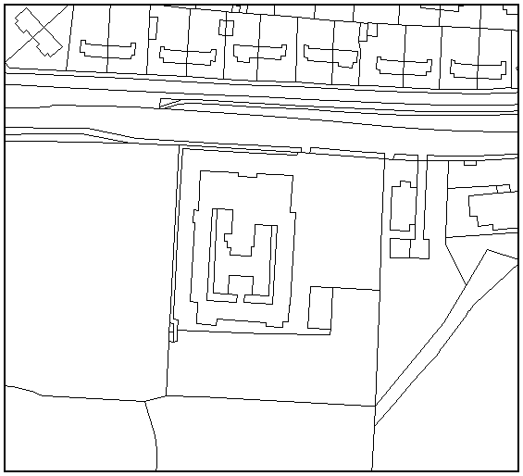

Location | How I feel here (1-sad, 10- very happy) | Description
1

2

3

4

5

6

7

8

9

10

How to use the sheet

Using an overhead map of the school (obtainable by subscribing to the BECTa Map Pilot project (see ‘Accessing Digital Maps’ document in this resource) or by contacting your LEA representatives responsible for GIS data), children visit up to 10 areas around their school grounds (it can be less if desired).

At each location, pupils can mark its position on the map and, in this case, give a score to reflect how positive or negative their feelings are towards each place with a brief reason why. Photographs of each location can also be taken to add to the GIS database.

A similar data collection exercise can be carried out for other GIS projects, e.g. recording the temperature in each location to see where best to grow plants or giving a score for amounts of litter found to identify where bins should be placed.

